

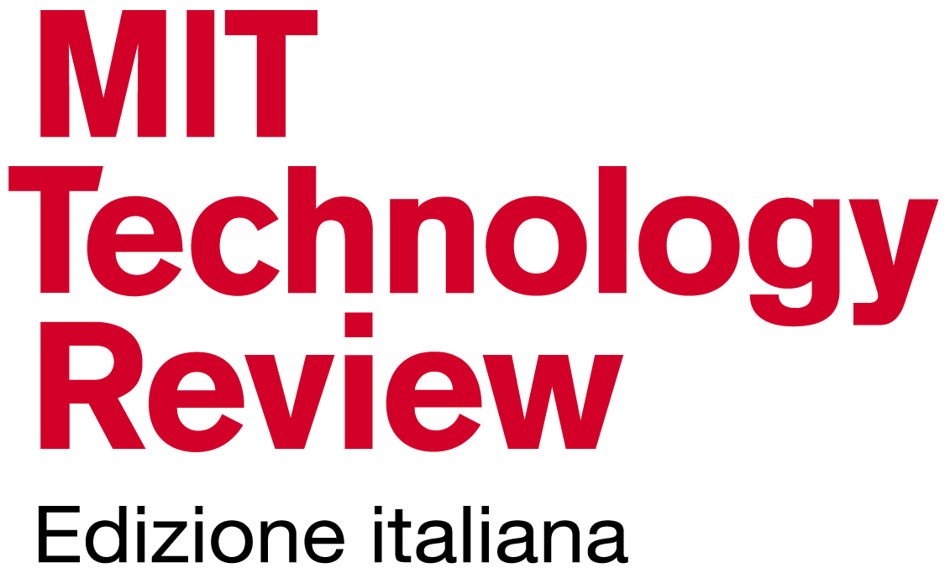



Research Innovation & Entrepreneurship Forum

**in cooperation with** 

**Innovators Under 35 Italy**

**Innovators Under 35 Italy** is jointly promoted by MIT Technology Review (Italian Edition) and by the Research Innovation Entrepreneurship Forum, University of Padua with the cooperation of Netval. It aims to collect and support the best innovative ideas and projects of applied research developed in Italy, with relevant potential for the creation of technology based companies.

**Innovators Under 35 Italy** is open to everyone who has an innovative project or who had already started a company and needs to build connections with other researchers, innovators, investors.

Established in 1999, **the Innovators Under 35** (previously called TR35) each year recognizes outstanding innovators under the age of 35. The awards span a wide range of fields, including biotechnology, materials, computer hardware, energy, transportation and the Internet. The promoters are searching for individuals whose superb technical work holds great promise to shape the next decades. Their goal is to recognize the development of new technology or the creative application of existing technologies to solve problems. They also reward ingenious and elegant work that matters to the world at large in a particular field or industry.

**Objectives**

The main aims of **Innovators Under 35** **Italy** are:

1. Highlighting the importance of scientific research for economic and social development

2. Presenting best innovative ideas and projects developed in Italy

3. Finding financial resources in order to support research and innovation projects

4. Promoting the entrepreneurial culture based on innovation

**Awards**

The best 10 innovators under 10:

**>** Will be published on MIT Technology Review Italia and in the website www.technologyreview.it; Will be published also in the official website of the Research Innovation Entrepreneurship Forum;

**>** Will be invited to present their project within the **Research Innovation and Entrepreneurship Forum, in Padua, on April 21, 2015**;

**>** Will be admitted to the selection of the global Innovators Under 35 of MIT Technology Review.

**The best 2 innovators will have the opportunity to be at MIT to meet scientists and/or entrepreneurs relevant for their research/entrepreneurial projects.**

**Criteria**

The competition is open to everyone who has a brilliant idea and has already developed a project based on technological innovation and applied research. **Every field of research will be accepted**. People coming from Universities and Research Centers, start-ups, medium to small companies, large corporations, no profit organizations, are encouraged to participate.

**Innovators Under 35** **Italy** applicants must be under the age of 35 on October 1, 2014 (born after October 1, 1979).

**Application procedures**

In order to compete, you are requested to present an idea based on technological innovation or the results of applied research. The idea and the results must be the original outcome of the efforts of the single participant.

If you want to participate, please complete the online application that you find at **www.rieforum.org/IU35**, and in [www.technologyreview.it](http://www.technologyreview.it) in all its fields. The application should be received by **February 15, 2015**.

(The guidelines are on the websites [www.rieforum.org](http://www.rieforum.org) and [www.technologyreview.it](http://www.technologyreview.it). For any information about the online application, please send an e-mail to [debora.vivenzi@unipd.it](mailto:debora.vivenzi@unipd.it)

**Evaluation**

A Scientific Committee will evaluate the projects. The Committee will include professors, researchers from different Universities, high-tech entrepreneurs, managers, seed and venture capitalists.

The main criteria for the evaluation are the following: originality of the results, degree of innovation, impact of potential applications and their economic and social consequences. Each project will be evaluated along with the following criteria:

**The impact of the project:** we want to reward people who introduce new and better solutions that change the way people live or work;

**The style:** we want to reward elegant and brilliant solutions and the multidisciplinary perspective;

**The challenge:** we want to reward projects that have ambitious targets;

We want to reward original projects that people are currently working on.

For further information, please visit: **www.rieforum.org** and [www.technologyreview.it](http://www.technologyreview.it)

**PARTNERSHIP**

